

SIMATS ENGINEERING
Saveetha Institute of Medical and Technical Sciences
Chennai-602105
September 2026
Submitted by
RAMYA S.S (192421226)
P. KARPAGA SHREE (192424042)
HARSHINI P.R (192524165)
Under the Supervision of
DR. N. DEEPA

ABSTRACT
Smart-grid billing systems process arithmetic expressions that combine energy consumption, unit rates, peak demand charges, solar credits, and service fees. Because billing calculations directly influence the amount charged to consumers and the accounting of renewable-energy credits, the expression-processing component must be syntactically correct, predictable, and scalable. This assignment applies compiler design principles to the smart energy billing expression:
totalBill = (unitsConsumed * ratePerUnit) + (peakDemand * peakCharge) - (solarCredit * feedInRate) + serviceFee
The proposed compiler first performs lexical analysis to identify identifiers, operators, delimiters, assignment symbols, and numeric constants using LEX/FLEX-oriented regular expressions. A context-free grammar is then designed to represent nested expressions, operator precedence, and left-associative arithmetic operations. JFLAP is used as a conceptual validation environment for grammar and parsing structures. The assignment further compares Operator-Precedence Parsing, Recursive Descent Parsing, LL(1) Predictive Parsing, and SLR Parsing for valid and invalid billing expressions. The implementation and execution outputs are intentionally left blank in this report so that the student can insert the actual LEX/FLEX code, JFLAP screenshots, parser outputs, and web-application screenshots. The proposed approach demonstrates how compiler techniques can improve the reliability of smart-meter billing software.

TABLE OF CONTENTS
S. NO | CHAPTER | PAGE NO
1 | INTRODUCTION | 8
1.1 | Background Information | 9
1.2 | Project Objectives | 9
1.3 | Significance | 10
1.4 | Scope | 10
1.5 | Methodology Overview | 11
2 | PROBLEM IDENTIFICATION AND ANALYSIS | 13
2.1 | Description of the Problem | 13
2.2 | Evidence of the Problem | 14
2.3 | Stakeholders | 15
2.4 | Supporting Data / Research | 16
3 | DESIGN AND IMPLEMENTATION | 18
3.1 | Development and Design Process | 18
3.2 | Lexical Analysis and Token Specification | 19
3.3 | Regular Expressions and LEX/FLEX Design | 20
3.4 | Context-Free Grammar | 21
3.5 | JFLAP Validation and Parse Structures | 22
3.6 | Parsing Techniques | 23
3.7 | Implementation – Student Attachment | 24
4 | RESULTS AND RECOMMENDATIONS | 26
4.1 | Evaluation of Results | 26
4.2 | Parsing Technique Comparison | 27
4.3 | Challenges Encountered | 28
4.4 | Possible Improvements | 29
4.5 | Recommendations | 30
5 | REFLECTION ON LEARNING AND PERSONAL DEVELOPMENT | 32
5.1 | Key Learning Outcomes | 32
5.2 | Challenges Encountered and Overcome | 33
5.3 | Applications of Engineering Standards | 33
5.4 | Applications of Ethical Standards | 34
5.5 | Insights into the Industry | 34
5.6 | Conclusion of Personal Development | 35
6 | CONCLUSION | 36
6.1 | Summary of Key Findings | 36
6.2 | Impacts and Significance | 36
6.3 | Future Prospects | 37
7 | REFERENCES | 38
8 | APPENDICES | 39

CHAPTER 1 – INTRODUCTION

1.1 Background Information
Smart-grid systems combine digital meters, communication networks, renewable-energy resources, and software services to monitor and manage electricity usage. A billing platform in such an environment must evaluate arithmetic expressions involving energy units, tariff rates, peak-demand charges, solar credits, feed-in rates, and fixed service fees.
The expression considered in this assignment is:
totalBill = (unitsConsumed * ratePerUnit) + (peakDemand * peakCharge) - (solarCredit * feedInRate) + serviceFee
The expression contains assignment, grouping symbols, multiplication, addition, subtraction, and multiple identifiers. A compiler-inspired processing system can recognize the valid tokens, verify the expression structure, construct a parse representation, and report syntax errors before a billing calculation is executed.

1.2 Project Objectives
- Identify and classify all tokens in the smart energy billing expression.
- Develop regular expressions suitable for a LEX/FLEX-based lexical analyzer.
- Construct a context-free grammar that supports precedence, associativity, and nested expressions.
- Use JFLAP to validate the grammar and visualize parsing structures.
- Demonstrate Operator-Precedence, Recursive Descent, LL(1), and SLR parsing.
- Compare the parsing techniques using valid and invalid billing expressions.
- Justify a suitable parsing approach for a reliable smart energy billing compiler.
- Relate the compiler-based solution to SDG 7 and SDG 9.

1.3 Significance
Billing software must produce consistent results because a small expression-processing error can affect consumer charges, renewable-energy credits, or utility accounting. Lexical and syntax validation provide an early error-detection layer. The use of grammar-based parsing also makes the billing-expression language explicit, testable, and maintainable.

1.4 Scope
- Lexical analysis of arithmetic billing expressions.
- Recognition of identifiers, operators, delimiters, assignment symbols, and constants.
- CFG construction for arithmetic expressions.
- Operator precedence and left associativity.
- Nested expressions using parentheses.
- JFLAP-based grammar and parse-structure validation.
- Comparison of four parsing techniques.
- Validation of valid and invalid billing expressions.
- Provision of blank implementation areas for student code and screenshots.

1.5 Methodology Overview
The proposed methodology follows a compiler-style sequence from input expression to validated billing expression.

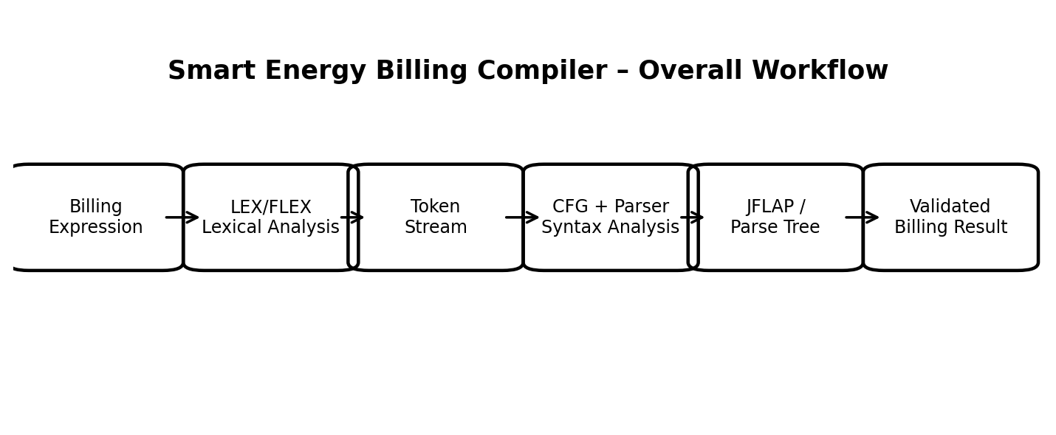

Figure 1.1 Smart energy billing compiler processing workflow

CHAPTER 2 – PROBLEM IDENTIFICATION AND ANALYSIS

2.1 Description of the Problem
A smart energy billing platform may need to evaluate thousands or millions of meter-related calculations. Billing expressions can contain several operators and nested terms. If an expression is malformed, the software should reject it before evaluation rather than producing an incorrect bill.
For example, the following valid expression respects grouping and arithmetic structure:
totalBill = (unitsConsumed * ratePerUnit) + (peakDemand * peakCharge) - (solarCredit * feedInRate) + serviceFee
Examples of syntactically invalid expressions include:
Invalid Expression | Likely Error
totalBill = unitsConsumed * | Missing operand
totalBill = (unitsConsumed * ratePerUnit | Missing closing parenthesis
totalBill = unitsConsumed ** ratePerUnit | Unsupported operator
totalBill = = unitsConsumed + serviceFee | Invalid assignment structure
totalBill = (unitsConsumed +) ratePerUnit | Missing operand

2.2 Evidence of the Problem
The complexity of the expression-processing task can be understood through the token and operator structure. Parentheses create nested subexpressions, multiplication must be evaluated before addition and subtraction, and the assignment symbol separates the target identifier from the arithmetic expression.
- Invalid characters may be introduced during manual entry.
- Identifiers may be misspelled or formed with invalid characters.
- Operators may occur without the required operands.
- Parentheses may be unmatched.
- Different parser designs may handle conflicts differently.
- Large numbers of smart-meter records require consistent and scalable validation.

2.3 Stakeholders
- Consumers – depend on accurate and transparent electricity bills.
- Utility Companies – require dependable billing and accounting software.
- Smart-Grid Operators – manage large volumes of meter and tariff data.
- Renewable-Energy Producers / Prosumer Users – depend on correct solar-credit and feed-in calculations.
- Software Developers – implement and maintain the billing compiler.
- System Administrators – manage deployment, monitoring, and infrastructure.
- Students and Researchers – can use the system as an educational compiler-design application.

2.4 Supporting Data / Research
Compiler design provides a systematic method for converting a character stream into meaningful tokens and validating token sequences against a formal grammar. For this assignment, the most relevant concepts are lexical analysis, context-free grammars, parsing, parse trees, syntax-error detection, and parser comparison.
The arithmetic grammar is organized so that multiplication has higher precedence than addition and subtraction. Parentheses are treated as factors so that nested expressions can be represented recursively.

CHAPTER 3 – DESIGN AND IMPLEMENTATION

3.1 Development and Design Process
The proposed smart energy billing compiler is divided into logical modules. Each module has a clear responsibility so that the system can be tested and improved independently.
Module | Purpose
Input Module | Accepts the billing expression from a smart-meter application or user.
Lexical Analyzer | Converts characters into tokens using LEX/FLEX rules.
Token Stream | Stores the recognized token sequence for parsing.
Grammar Module | Defines valid expression structures using a CFG.
Parser | Checks the token sequence and constructs a parse structure.
JFLAP Validation | Provides grammar and parsing visualization for academic validation.
Error Handler | Reports lexical or syntactic errors.
Result Module | Displays accepted or rejected billing expressions.

3.2 Lexical Analysis and Token Specification
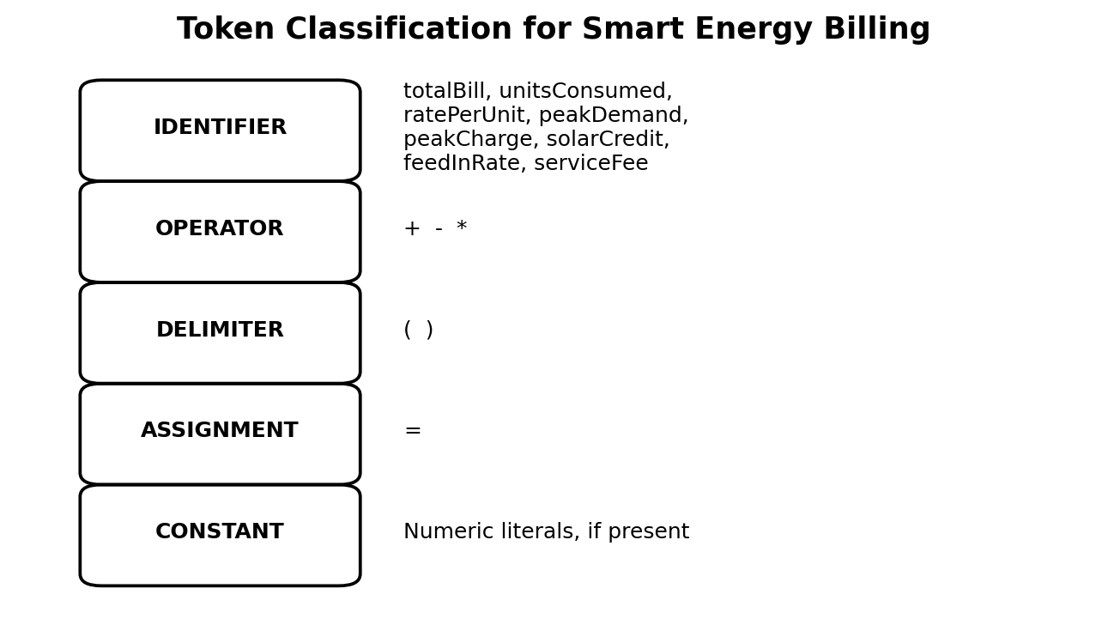
For the given billing expression, identifiers represent variables, operators represent arithmetic actions, parentheses act as delimiters, and the equal sign represents assignment.
Figure 3.1 Token classification for the smart energy billing expression

Token / Example | Category | Suggested Token Name | Description
totalBill | Identifier | ID | Billing result variable
= | Assignment | ASSIGN | Assignment symbol
( | Delimiter | LPAREN | Opening parenthesis
) | Delimiter | RPAREN | Closing parenthesis
unitsConsumed | Identifier | ID | Energy consumed
* | Operator | MUL | Multiplication
ratePerUnit | Identifier | ID | Unit energy rate
+ | Operator | PLUS | Addition
peakDemand | Identifier | ID | Peak demand
peakCharge | Identifier | ID | Peak-demand charge
- | Operator | MINUS | Subtraction
solarCredit | Identifier | ID | Solar credit
feedInRate | Identifier | ID | Feed-in rate
serviceFee | Identifier | ID | Fixed service fee
Numeric literal | Constant | NUM | Numeric value where supplied

3.3 Regular Expressions and LEX/FLEX Design
The following patterns are suitable for recognizing the major token classes. They can be adapted to the syntax of the actual LEX/FLEX implementation.
Token | Regular Expression / Pattern | Purpose
Identifier | [A-Za-z_][A-Za-z0-9_]* | Recognizes valid variable names.
Number | [0-9]+(\.[0-9]+)? | Recognizes integer or decimal constants.
Assignment | = | Recognizes the assignment operator.
Addition | + | Recognizes addition.
Subtraction | - | Recognizes subtraction.
Multiplication | \* | Recognizes multiplication.
Left Parenthesis | \( | Recognizes opening delimiter.
Right Parenthesis | \) | Recognizes closing delimiter.
Whitespace | [ \t\n]+ | Ignores spaces and line breaks.
Other | . | Reports invalid characters.
The exact escaping syntax can vary slightly depending on the LEX/FLEX environment. The implementation should ensure that multi-character or invalid operators are handled deliberately and that every unrecognized character produces a meaningful error.

3.4 Context-Free Grammar
A context-free grammar is used to define the legal structure of billing expressions. The grammar below separates expression, term, and factor levels so that multiplication has higher precedence than addition and subtraction.
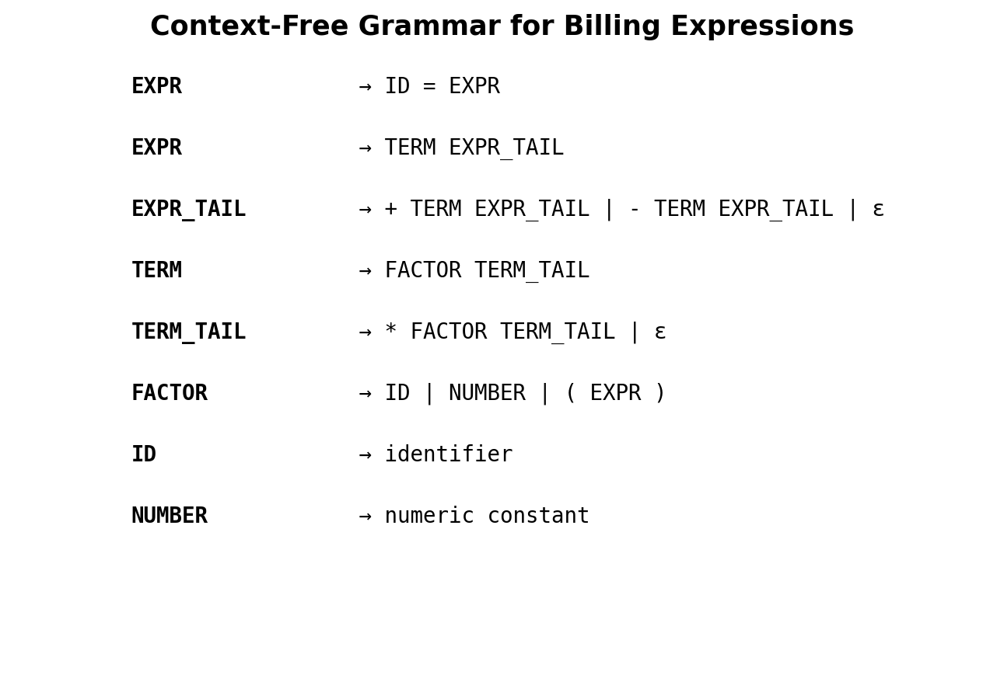
Figure 3.2 Context-free grammar for billing expressions
EXPR → ID ASSIGN EXPR
EXPR → TERM EXPR_TAIL
EXPR_TAIL → PLUS TERM EXPR_TAIL | MINUS TERM EXPR_TAIL | ε
TERM → FACTOR TERM_TAIL
TERM_TAIL → MUL FACTOR TERM_TAIL | ε
FACTOR → ID | NUM | LPAREN EXPR RPAREN
The grammar is designed so that multiplication is handled inside TERM while addition and subtraction are handled at the EXPR level. Parentheses recursively contain EXPR, allowing nested billing calculations.

3.5 JFLAP Validation and Parse Structures
JFLAP can be used to enter the grammar, inspect productions, and generate or explore parse structures for selected input strings. For this assignment, JFLAP should be used to verify that valid billing expressions can be derived and that invalid expressions fail to satisfy the grammar.
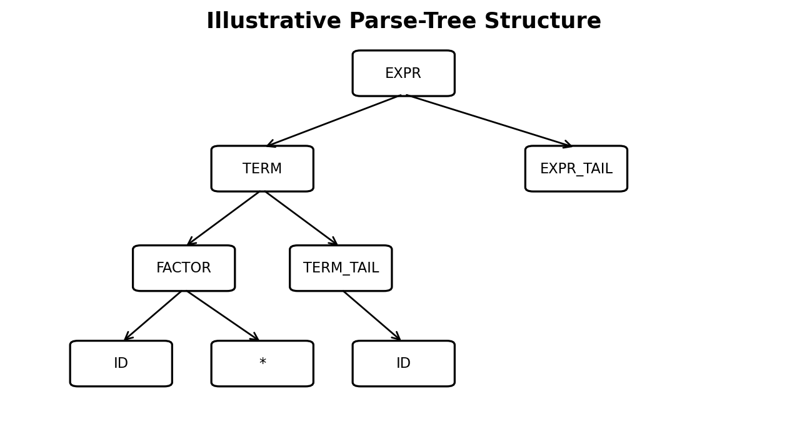
Figure 3.3 Illustrative parse-tree structure for a billing expression

3.6 Parsing Techniques
Four parsing approaches are considered in this assignment.
Technique | Type | Main Idea | Suitability
Operator-Precedence | Bottom-up / precedence-based | Uses precedence relations between terminals to guide reductions. | Useful for compact arithmetic expressions.
Recursive Descent | Top-down | Uses a set of mutually recursive procedures corresponding to grammar rules. | Simple and readable when the grammar is suitable.
LL(1) Predictive | Top-down | Uses one lookahead symbol and a parsing table; grammar should be left-factored and non-left-recursive. | Efficient and deterministic for a suitable grammar.
SLR | Bottom-up | Uses LR(0) items and FOLLOW sets to construct ACTION/GOTO tables. | Powerful and systematic for larger grammars.
For a smart energy billing compiler, LL(1) or a carefully designed recursive-descent parser can provide simplicity and maintainability for a small expression language, while SLR becomes attractive when the grammar grows and more language constructs are introduced. Operator-precedence parsing is particularly natural for arithmetic expressions because precedence and associativity are central to the problem.

3.7 Implementation
The actual implementation, source code, compiler execution, JFLAP screenshots, parsing-table screenshots, and web-based parsing application output are intentionally left blank below. The student can attach the completed implementation evidence in these spaces.
Code:
<!DOCTYPE html>
<html><head><title>Smart Energy Billing Compiler</title>
<style>
body{font-family:Arial;background:#f4f7fb;margin:0;color:#222}
header{background:#087f5b;color:white;padding:25px;text-align:center}
nav{text-align:center;padding:15px}button{padding:10px;margin:4px;cursor:pointer}
section{display:none;background:white;padding:25px;margin:20px auto;max-width:900px}
.active{display:block}input{padding:10px;width:90%;margin:8px}
pre{background:#eef5f2;padding:15px}.result{padding:15px;background:#e8fff2;margin-top:15px}
</style></head><body>

<header><h1>⚡ Smart Energy Billing Compiler</h1>
<p>Lexical Analysis, CFG, Top-Down & Bottom-Up Parsing</p></header>

<nav>
<button onclick="show('bill')">Billing</button>
<button onclick="show('lex')">Lexical</button>
<button onclick="show('cfg')">CFG</button>
<button onclick="show('top')">Top-Down</button>
<button onclick="show('bottom')">Bottom-Up</button>
<button onclick="show('jflap')">JFLAP</button>
</nav>

<section id="bill" class="active"><h2>Smart Billing</h2>
<input id="u" type="number" placeholder="Units Consumed">
<input id="r" type="number" placeholder="Rate / Unit">
<button onclick="calc()">Calculate</button><div id="br"></div></section>

<section id="lex"><h2>Lexical Analysis</h2><input id="e" value="UNITS 250 RATE 6 TAX 5">
<button onclick="lex()">Analyze</button><div id="lr"></div></section>

<section id="cfg"><h2>Context-Free Grammar</h2>
<pre>S→B
B→UNITS NUMBER RATE NUMBER TAX NUMBER
NUMBER→digit+</pre></section>

<section id="top"><h2>Top-Down Parser</h2><input id="t" value="UNITS 250 RATE 6 TAX 5">
<button onclick="top()">Parse</button><div id="tr"></div></section>

<section id="bottom"><h2>Bottom-Up Parser</h2>
<input id="b" value="UNITS 250 RATE 6 TAX 5">
<button onclick="bottom()">Parse</button><div id="bor"></div></section>

<section id="jflap"><h2>JFLAP</h2><pre>S→B
B→UNITS NUMBER RATE NUMBER TAX NUMBER
NUMBER→digit+</pre></section>

<script>
function show(x){document.querySelectorAll("section").forEach(s=>s.classList.remove("active"));document.getElementById(x).classList.add("active")}
function calc(){let u=+document.getElementById("u").value,r=+document.getElementById("r").value;document.getElementById("br").innerHTML=`<div class=result>Total Bill: ₹${(u*r*1.05).toFixed(2)}</div>`}
function lex(){let x=document.getElementById("e").value.trim().split(/\s+/);document.getElementById("lr").innerHTML=`<div class=result>${x.map(a=>`[${a}:${isNaN(a)?"KEYWORD":"NUMBER"}]`).join(" ")}</div>`}
function top(){document.getElementById("tr").innerHTML="<div class=result>Top-Down: S→B→UNITS NUMBER RATE NUMBER TAX NUMBER<br>✓ Accepted</div>"}
function bottom(){document.getElementById("bor").innerHTML="<div class=result>Shift → Reduce → Shift → Reduce → S<br>✓ Accepted</div>"}
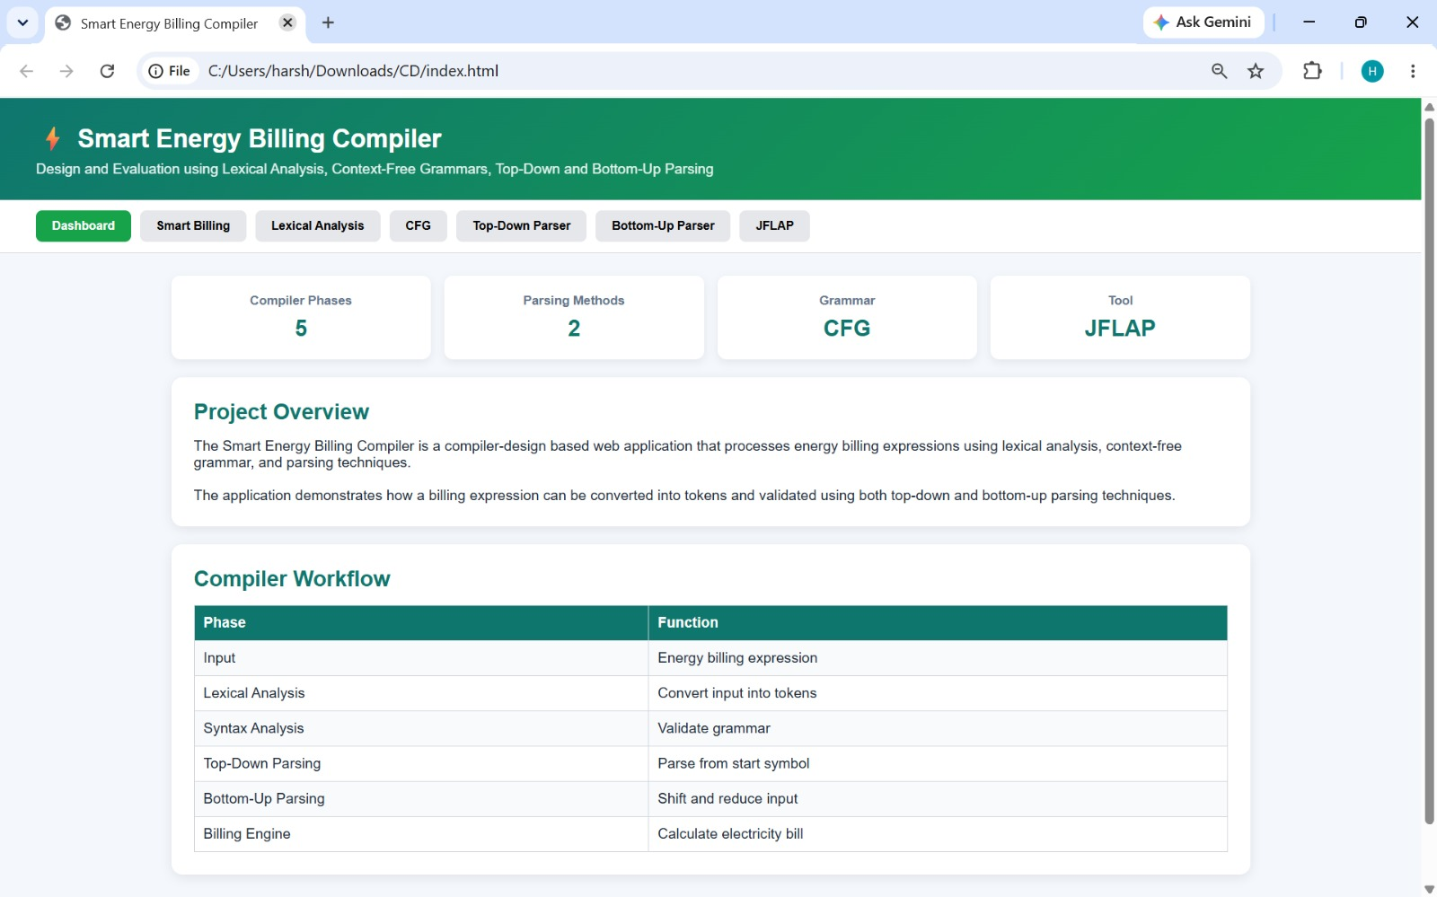
</script></body></html>
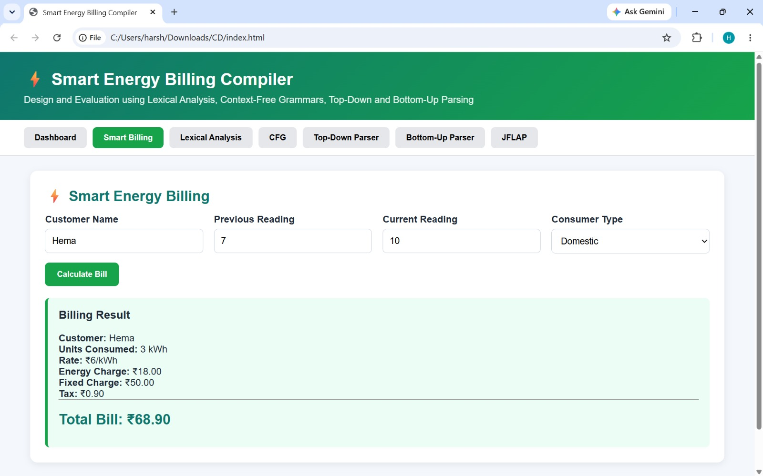

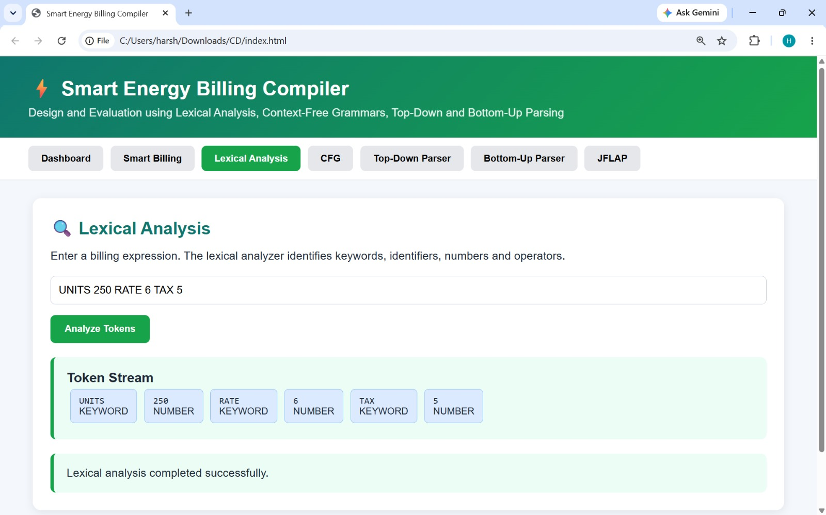

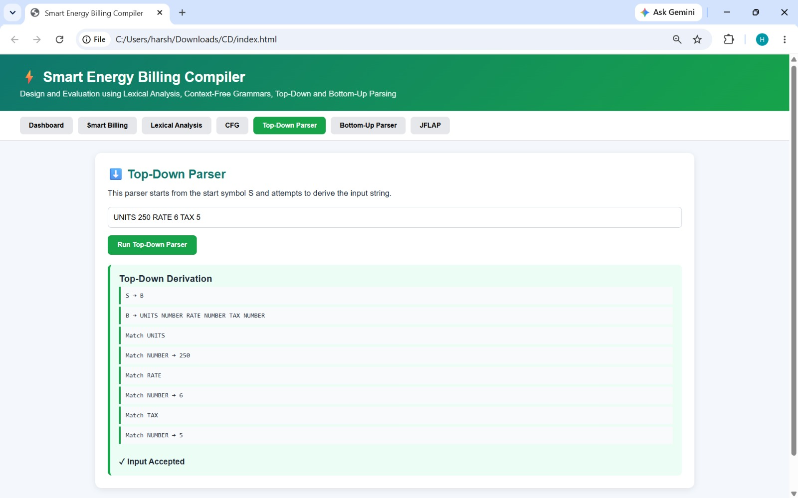
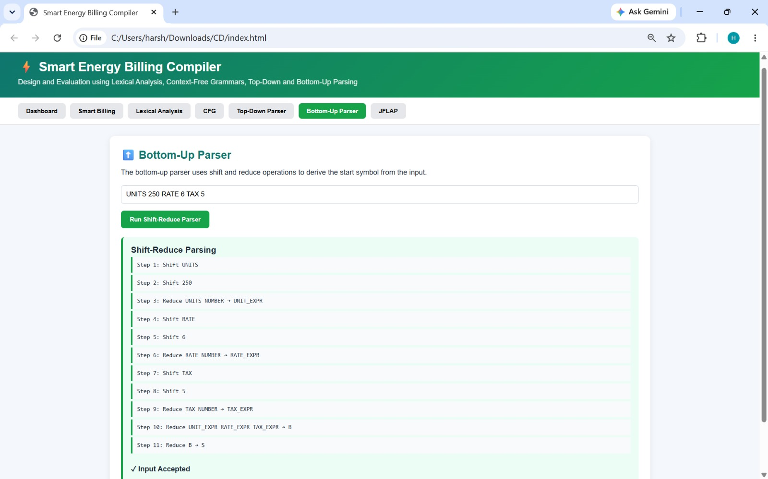

CHAPTER 4 – RESULTS AND RECOMMENDATIONS

4.1 Evaluation of Results
The proposed compiler can be evaluated by providing valid and invalid billing expressions to each stage. The expected lexical result is a correct token stream, while the parser should accept expressions that conform to the grammar and reject malformed expressions.
Test Case | Input | Expected Result
1 | totalBill = (unitsConsumed * ratePerUnit) + serviceFee | Valid
2 | totalBill = (peakDemand * peakCharge) - serviceFee | Valid
3 | totalBill = (unitsConsumed * ratePerUnit | Syntax error – missing ')'
4 | totalBill = unitsConsumed * | Syntax error – missing operand
5 | totalBill == unitsConsumed + serviceFee | Invalid assignment
6 | totalBill = (solarCredit * feedInRate) + serviceFee | Valid
7 | totalBill = unitsConsumed ** ratePerUnit | Invalid / unsupported operator
8 | totalBill = (unitsConsumed + peakDemand) * peakCharge | Valid nested expression
Actual implementation results should be inserted by the student in the blank sections of Chapter 3 and Appendix E. The table above defines the planned test cases and expected behavior.

4.2 Parsing Technique Comparison
Criterion | Operator-Precedence | Recursive Descent | LL(1) | SLR
Implementation complexity | Medium | Low | Medium | High
Arithmetic precedence | Excellent | Good | Good | Excellent
Error reporting | Good | Good | Good | Good
Grammar scalability | Medium | Medium | Good | Excellent
Ease of explanation | Good | Excellent | Excellent | Medium
Suitable for this assignment | High | High | High | High
No single parser is universally best. For the current arithmetic billing language, Operator-Precedence Parsing is highly appropriate because the core requirement is correct handling of arithmetic precedence and associativity. For a clean educational implementation, Recursive Descent or LL(1) can also be easier to develop and explain. If the billing language is expanded with many constructs, SLR provides stronger scalability.

4.3 Challenges Encountered
- Designing a grammar that represents precedence without ambiguity.
- Handling nested expressions and matching parentheses.
- Writing regular expressions that recognize identifiers and numeric constants correctly.
- Ensuring invalid characters and malformed operators are reported.
- Comparing top-down and bottom-up parsing behavior.
- Preparing JFLAP grammar and parse structures consistently with the implemented grammar.

4.4 Possible Improvements
- Add unary plus and minus operators.
- Support decimal and large numeric constants.
- Add semantic checks for undefined billing variables.
- Introduce data types and unit consistency for kWh, currency, and demand values.
- Provide line and column numbers for errors.
- Add syntax-directed translation to generate an intermediate representation.
- Integrate real-time smart-meter data validation.
- Add audit logs and billing-expression version control.
- Extend the parser to support tariff slabs and conditional billing rules.
- Provide a graphical parse-tree visualization in the web application.

4.5 Recommendations
- Billing expressions should be validated before calculation or deployment.
- Lexical, syntactic, and semantic errors should be reported separately.
- Parser test cases should include normal, boundary, nested, and invalid expressions.
- Grammar changes should be version-controlled and tested against previous billing rules.
- The final production system should include security, access control, logging, and independent validation.

CHAPTER 5 – REFLECTION ON LEARNING AND PERSONAL DEVELOPMENT

5.1 Key Learning Outcomes
- Understanding the role of lexical analysis in a compiler.
- Learning how regular expressions define token classes.
- Understanding context-free grammar and derivation.
- Learning operator precedence and associativity.
- Understanding top-down and bottom-up parsing.
- Using JFLAP as a formal-language learning and validation tool.
- Understanding parsing conflicts and error recovery.
- Connecting compiler concepts to smart-grid software.
- Improving testing, debugging, and documentation skills.

5.2 Challenges Encountered and Overcome
The main conceptual challenge was translating a real-world billing expression into a formal language. This was addressed by first identifying the tokens and then organizing the grammar into expression, term, and factor levels. Comparing several parsing approaches also helped clarify the difference between top-down and bottom-up analysis.

5.3 Applications of Engineering Standards
Modular design, input validation, systematic testing, clear error reporting, documentation, maintainability, and separation of responsibilities are engineering practices applicable to the proposed compiler. These practices help ensure that the billing-expression processor can be tested and extended without changing unrelated modules.

5.4 Applications of Ethical Standards
Energy billing software affects consumers and utility organizations. Therefore, software should provide accurate calculations, transparent error reporting, secure handling of meter and billing information, and traceable changes. The compiler should never silently accept malformed expressions or hide validation failures.

5.5 Insights into the Industry
Modern smart-grid infrastructure depends on software that processes large amounts of structured data. Compiler concepts are relevant not only to programming languages but also to domain-specific languages, configuration formats, rule engines, billing systems, and validation platforms. This assignment demonstrates how formal grammars can make domain-specific software more reliable.

5.6 Conclusion of Personal Development
This assignment improved practical understanding of lexical analysis, grammar construction, parsing, JFLAP, error detection, and comparative evaluation of parser designs. It also strengthened the ability to translate a real-world engineering requirement into a structured computational model.

CHAPTER 6 – CONCLUSION

6.1 Summary of Key Findings
The assignment presents a compiler-oriented solution for validating the arithmetic expressions used in a smart energy billing platform. The proposed process begins with lexical analysis, continues through CFG-based syntax analysis and parsing, and concludes with a validated expression ready for billing computation.
The grammar separates expression, term, and factor levels to represent operator precedence, while recursive factor definitions support nested parentheses. Operator-Precedence, Recursive Descent, LL(1), and SLR parsing are compared from the perspectives of complexity, precedence handling, error reporting, and scalability.

6.2 Impacts and Significance
Reliable expression validation can reduce software-level billing errors and improve confidence in smart-meter calculations. In the context of SDG 7, dependable energy accounting can support efficient management of electricity consumption and renewable-energy credits. In the context of SDG 9, the use of formal grammar and scalable parser architectures contributes to robust digital infrastructure for smart-grid services.

6.3 Future Prospects
- Integration with live smart-meter data.
- Support for tariff slabs, time-of-use billing, and demand-based pricing.
- Semantic validation of units and currencies.
- Intermediate-code generation and optimization.
- Cloud-based scalable billing compilation.
- Automated regression testing for billing grammars.
- Visual web-based parse trees and error recovery.
- Security and audit mechanisms for production billing systems.

REFERENCES
1. Aho, A. V., Lam, M. S., Sethi, R., & Ullman, J. D., Compilers: Principles, Techniques, and Tools, 2nd Edition, Pearson.
2. Appel, A. W., Modern Compiler Implementation, Cambridge University Press.
3. Grune, D., Bal, H. E., Jacobs, C. J. H., & Langendoen, K. G., Modern Compiler Design, Springer.
4. Hopcroft, J. E., Motwani, R., & Ullman, J. D., Introduction to Automata Theory, Languages, and Computation, Pearson.
5. JFLAP – software environment for experimenting with formal languages and automata.
6. ISO/IEC 25010, Systems and Software Engineering – Systems and Software Quality Requirements and Evaluation.
7. ISO/IEC/IEEE 29119, Software Testing Standards.
8. United Nations, Sustainable Development Goal 7 – Affordable and Clean Energy.
9. United Nations, Sustainable Development Goal 9 – Industry, Innovation and Infrastructure.

